B. Naveen Kumar

Program 1 -Generation of number series 1, 2, 3, 4…n

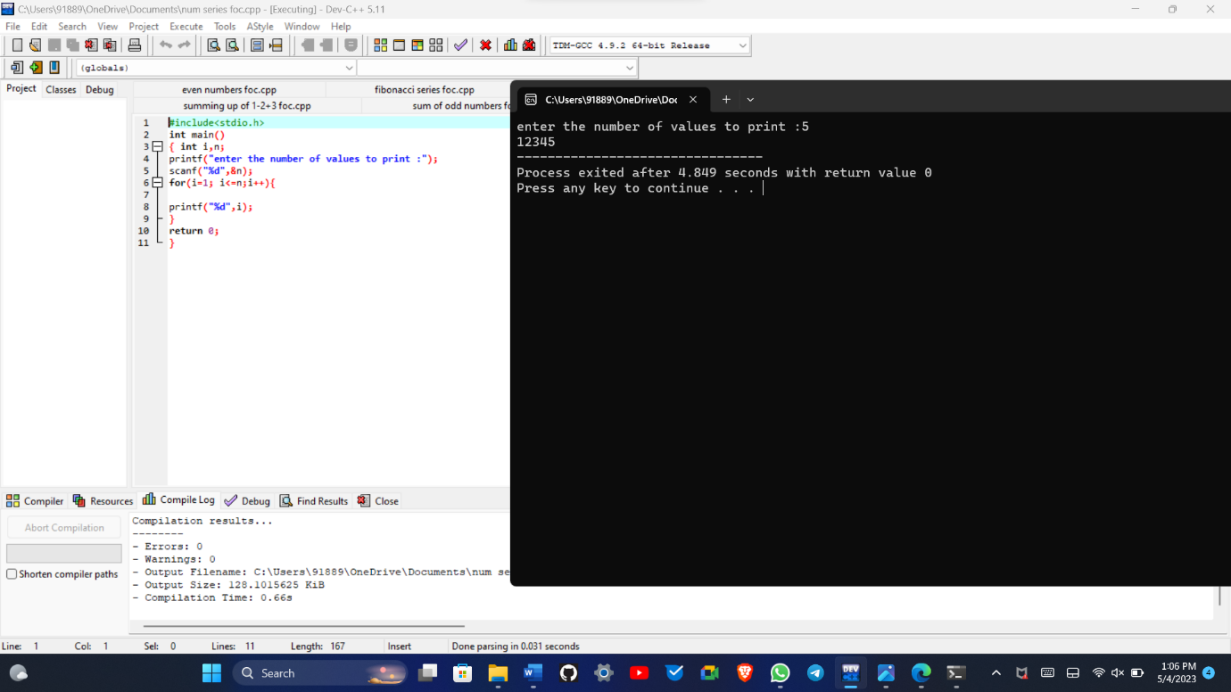

Program 2 -Generation of even number series 2, 4, 6, …..n

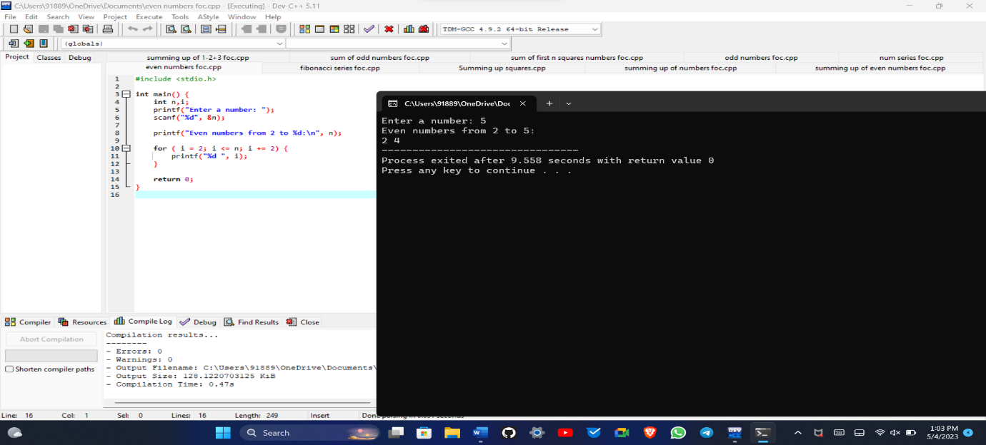

Program 3 -Generation of ODD number series 1, 3, 5, …..n

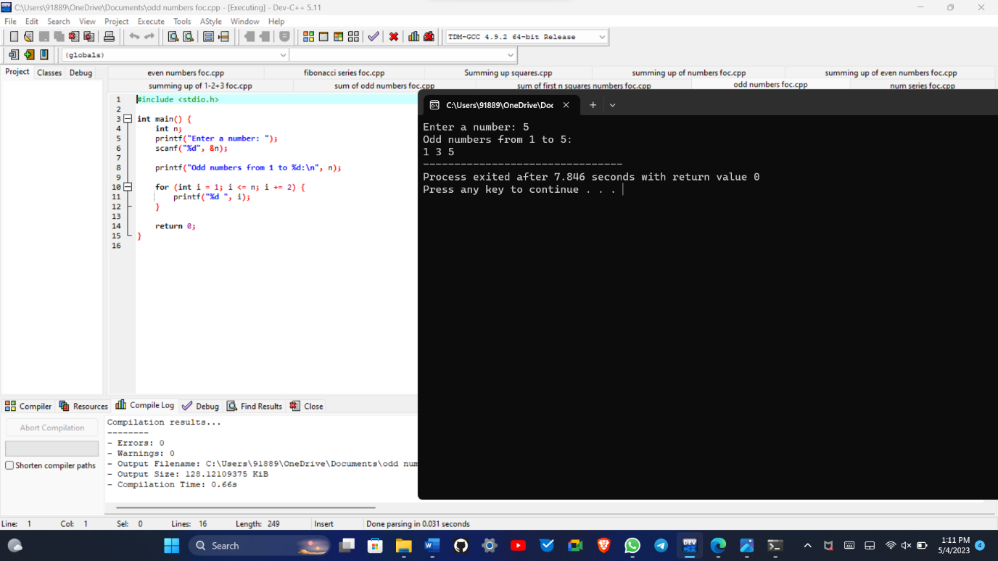

Program 4 - Generation of Fibonacci series 0, 1, 1, 2, 3, 5, 8, …..n

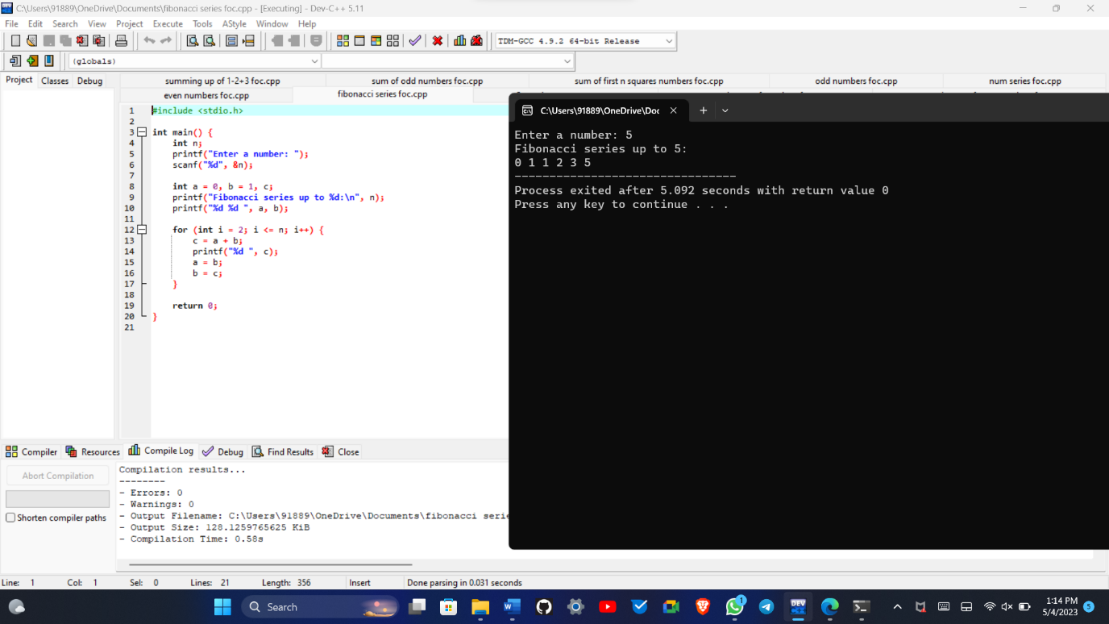

Program 5 - . Summing up series 1 + 2 + 3 + 4….. +n

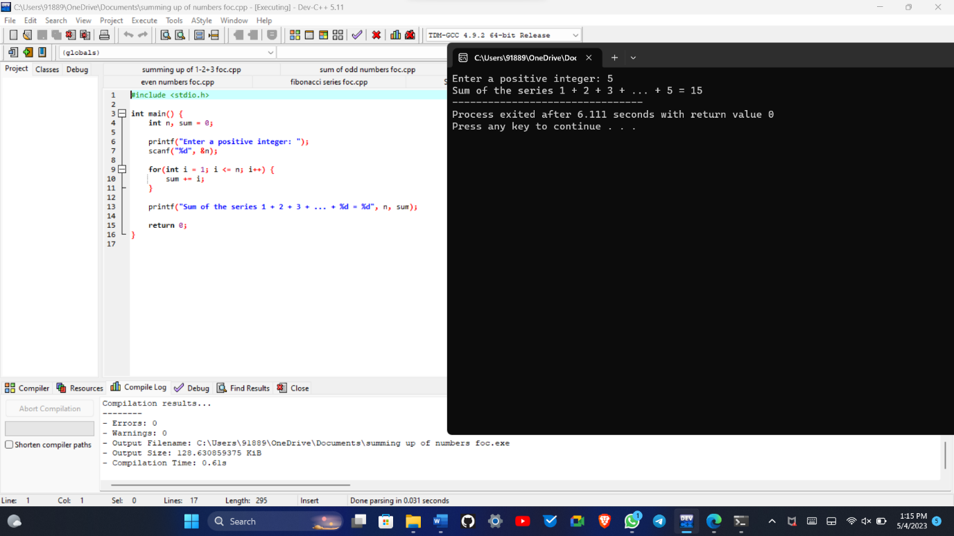

Program 6 - Summing up Even Number series

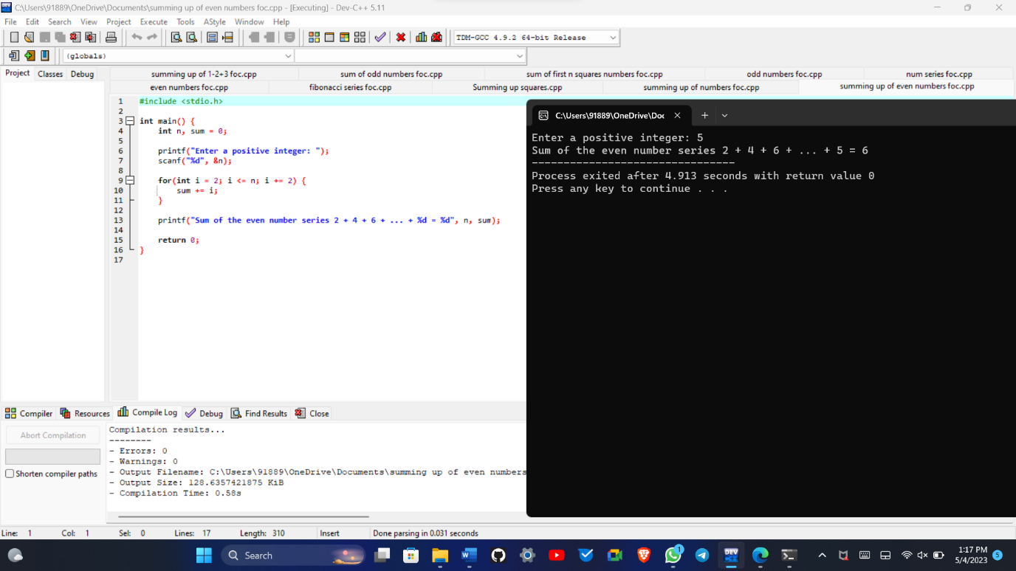

Program 7 - Summing up Odd Number series

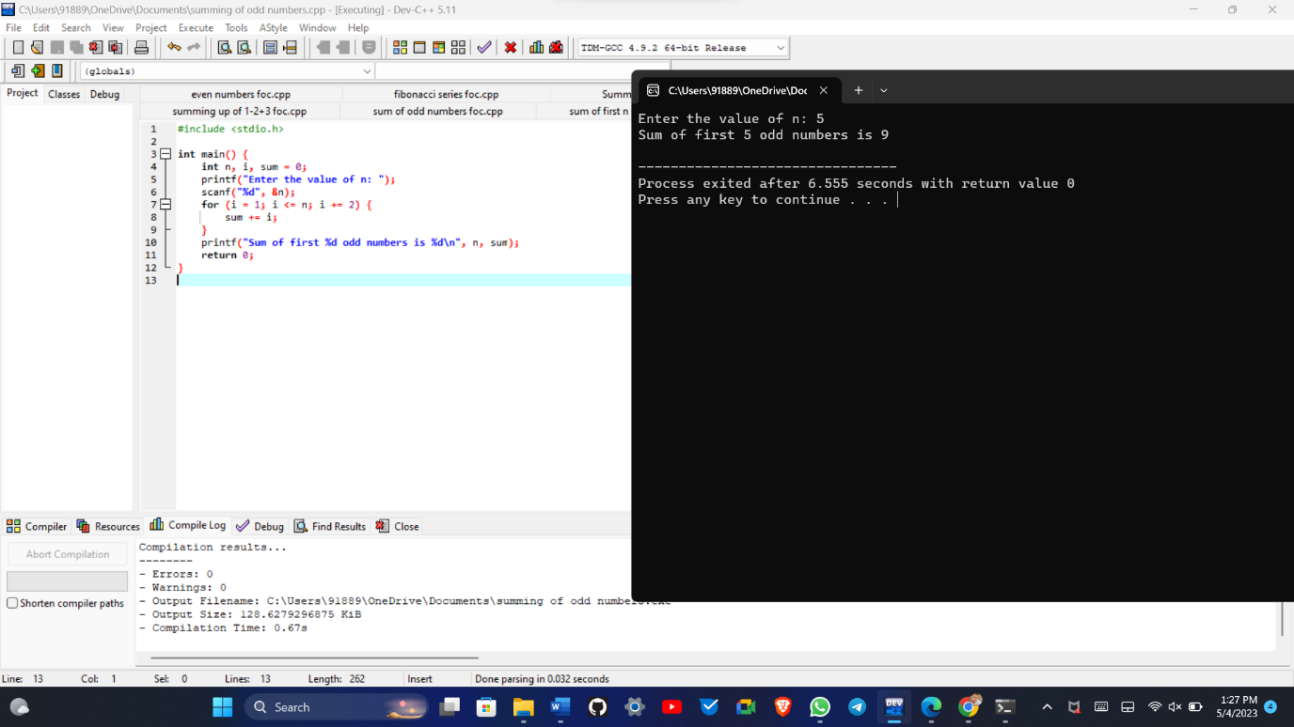

Program 8 - Summing up 1 – 2 + 3 – 4 + 5…. N

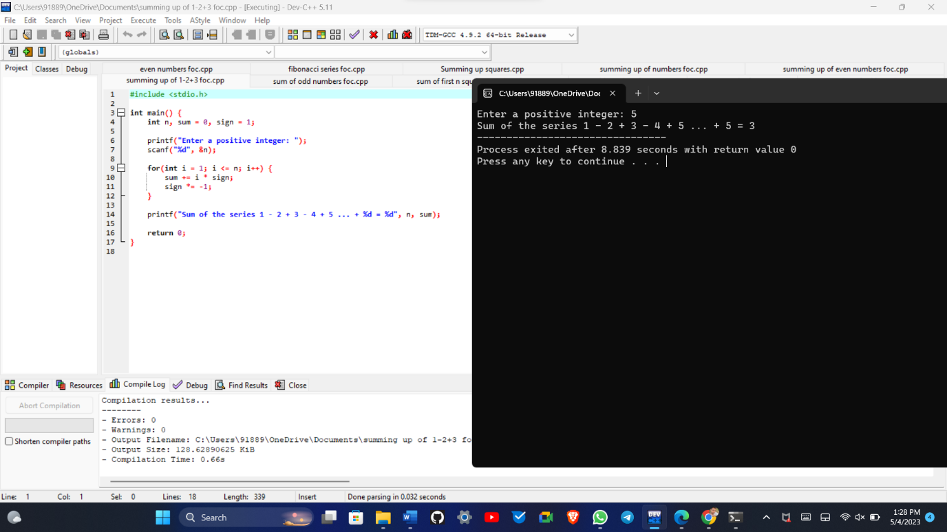

Program 9 - Summing up 1² + 2²+ 3² + 2²….. +n

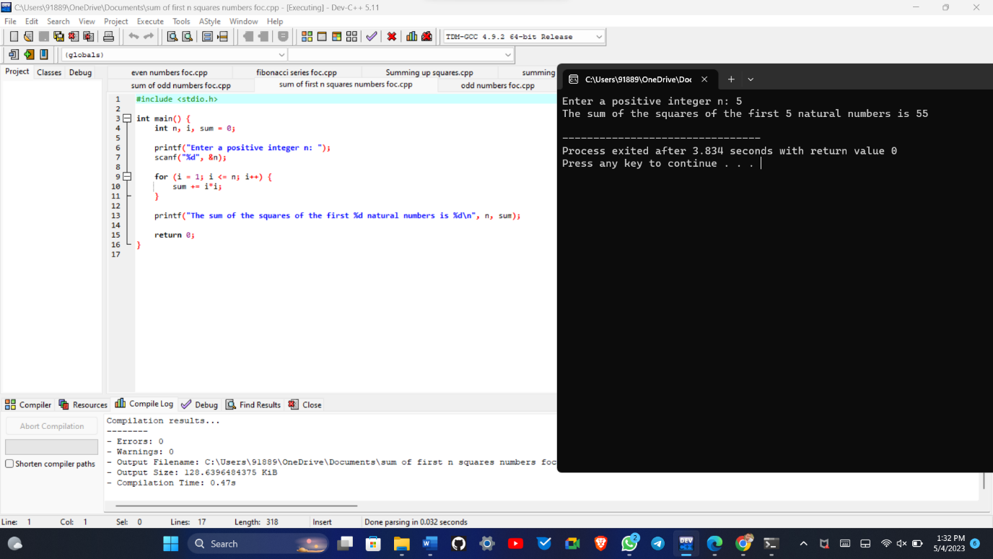

Program 10 -Summing up 2²+ 4² + 6² + 8² + ….. n²

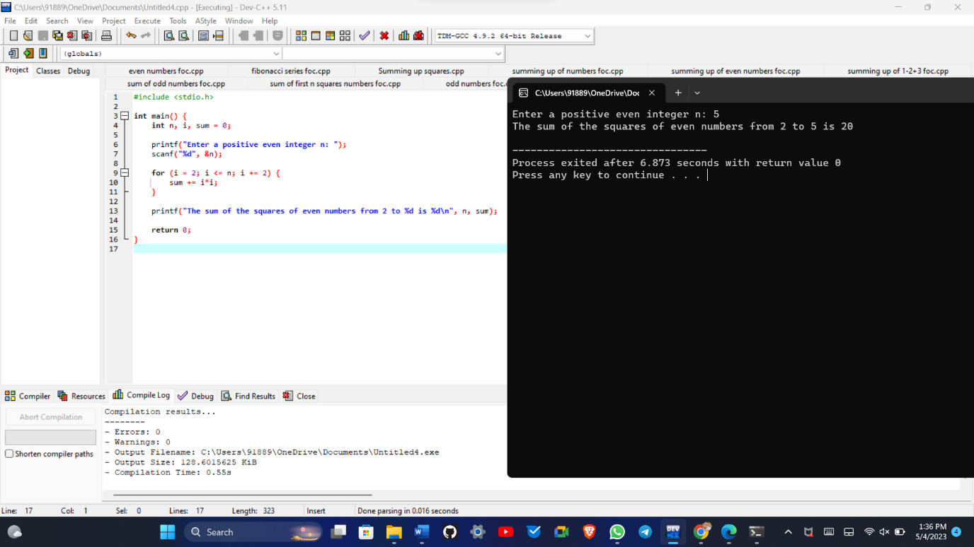

Program 11: Summing up 1¹+2²+3³+ …. Nⁿ

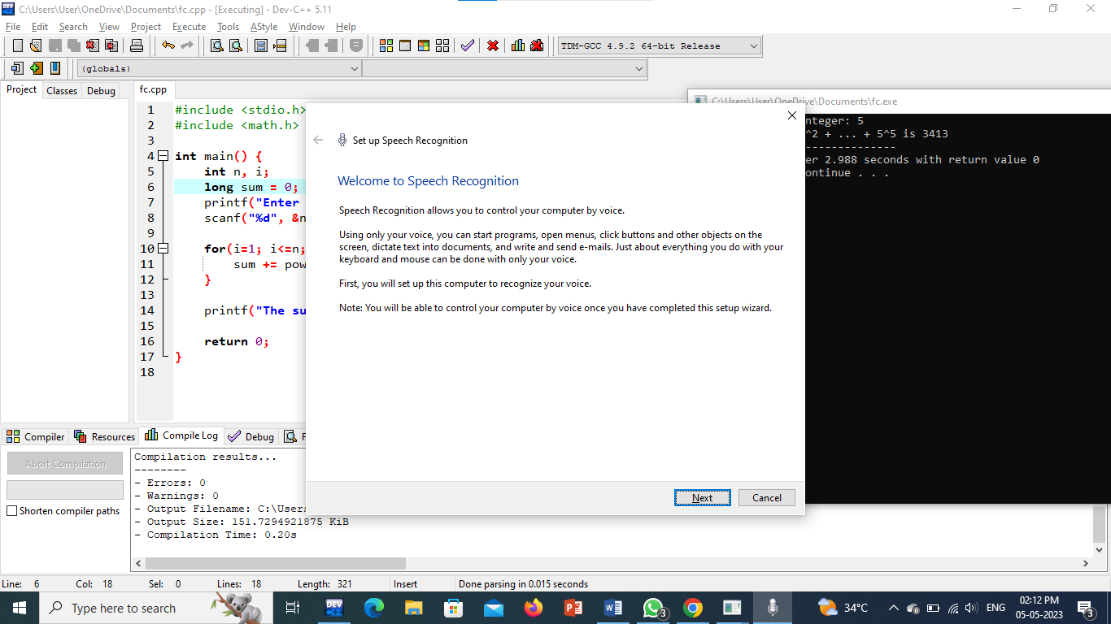

Program 12: Summing up squares of Odd numbers

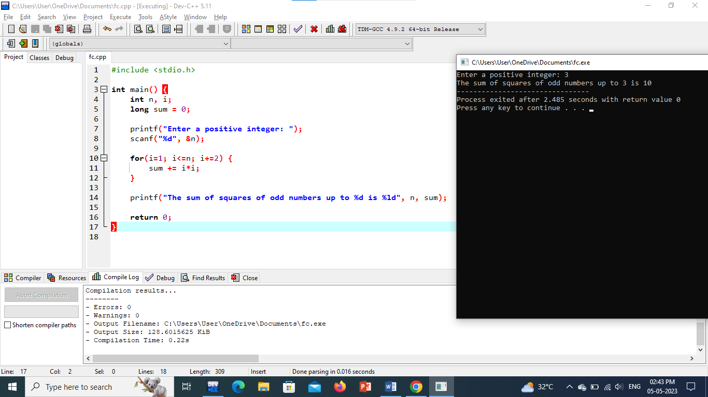

Program 13 : Summing up cubes of n numbers

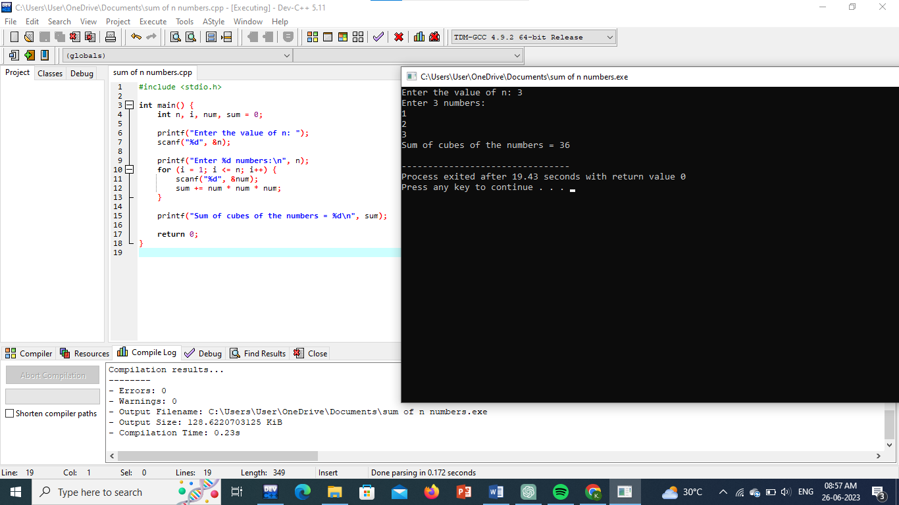

Program 14 : Product series (Factorial of a given number)

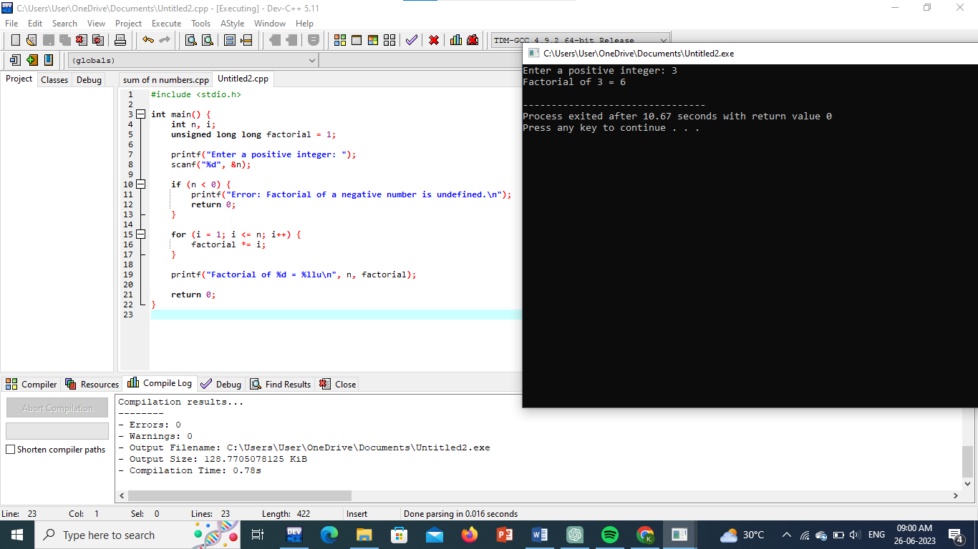

Program 15 : Finding given number is Armstrong or not

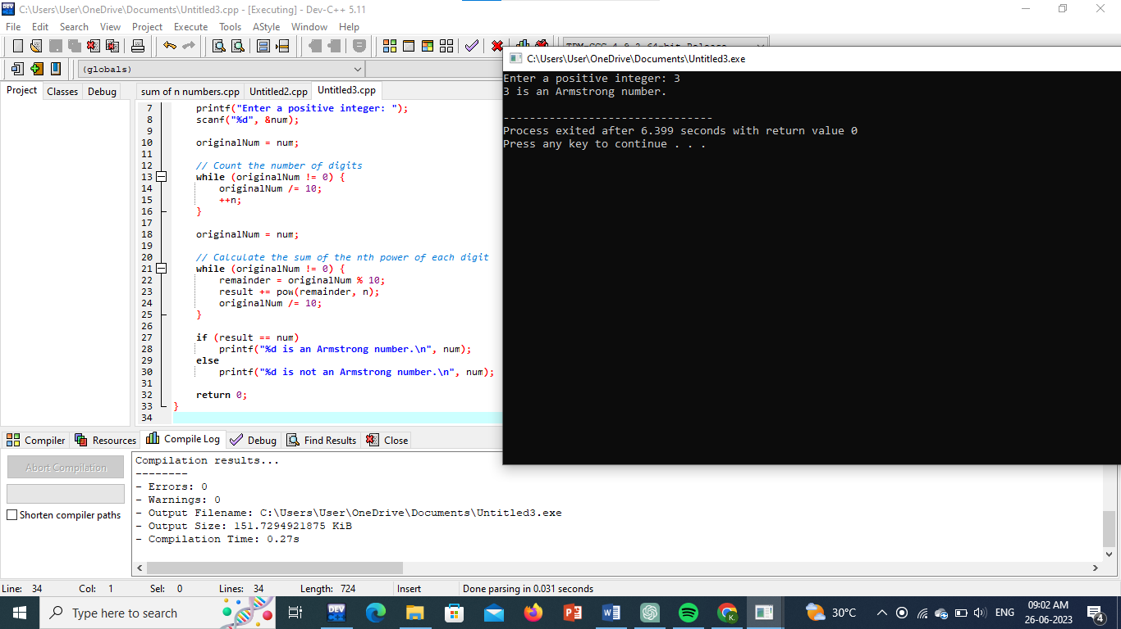

Program 16 : Summing up any n numbers and finding average

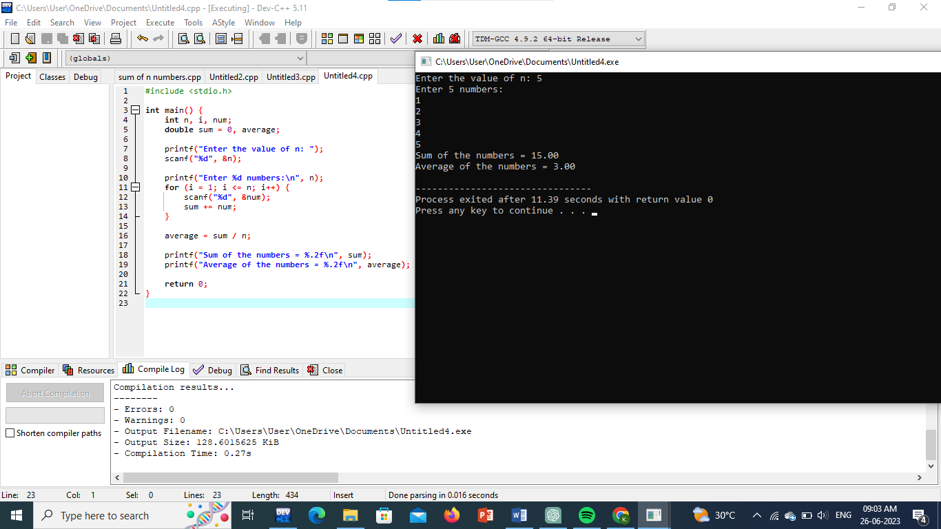

Program 17 : Printing digits of an integer number

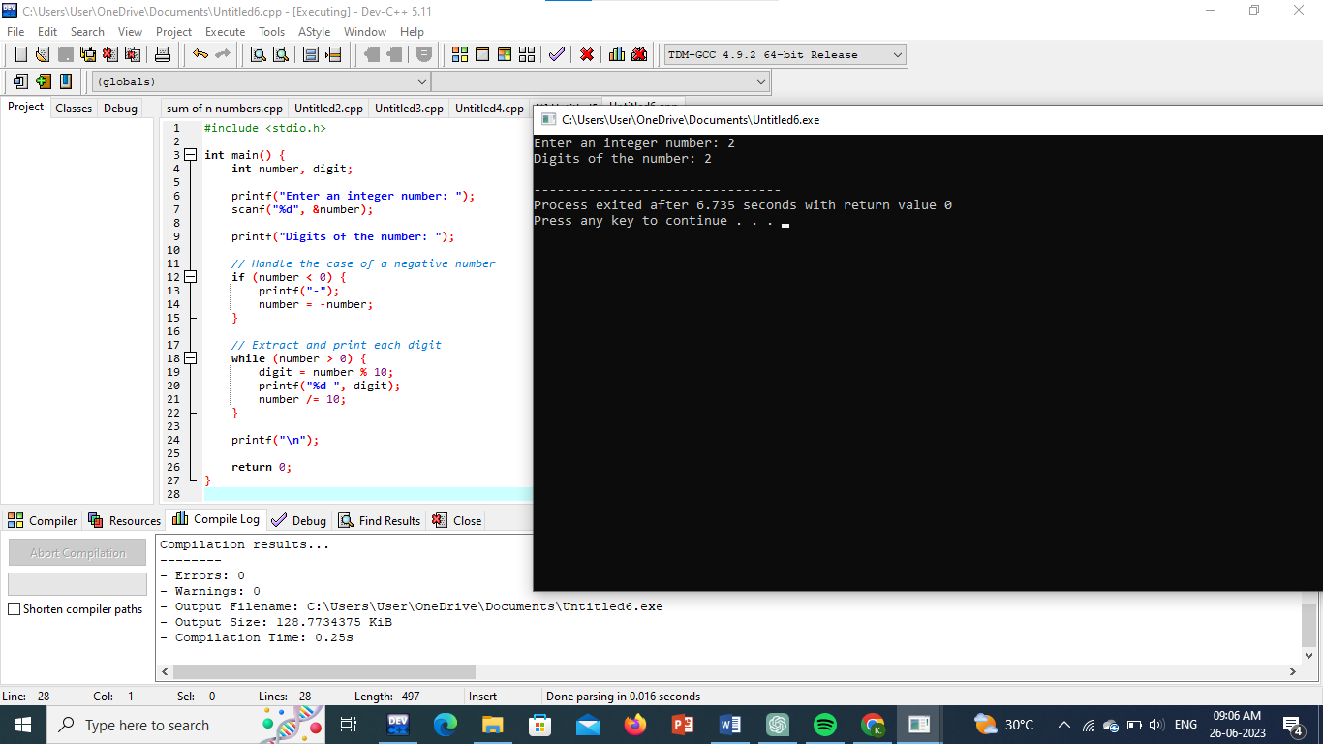

Program 18 : Summing up the digits of an integer number

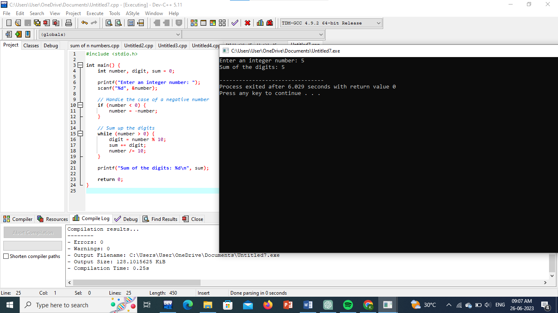

Program 19 : Revering the digits of an integer number

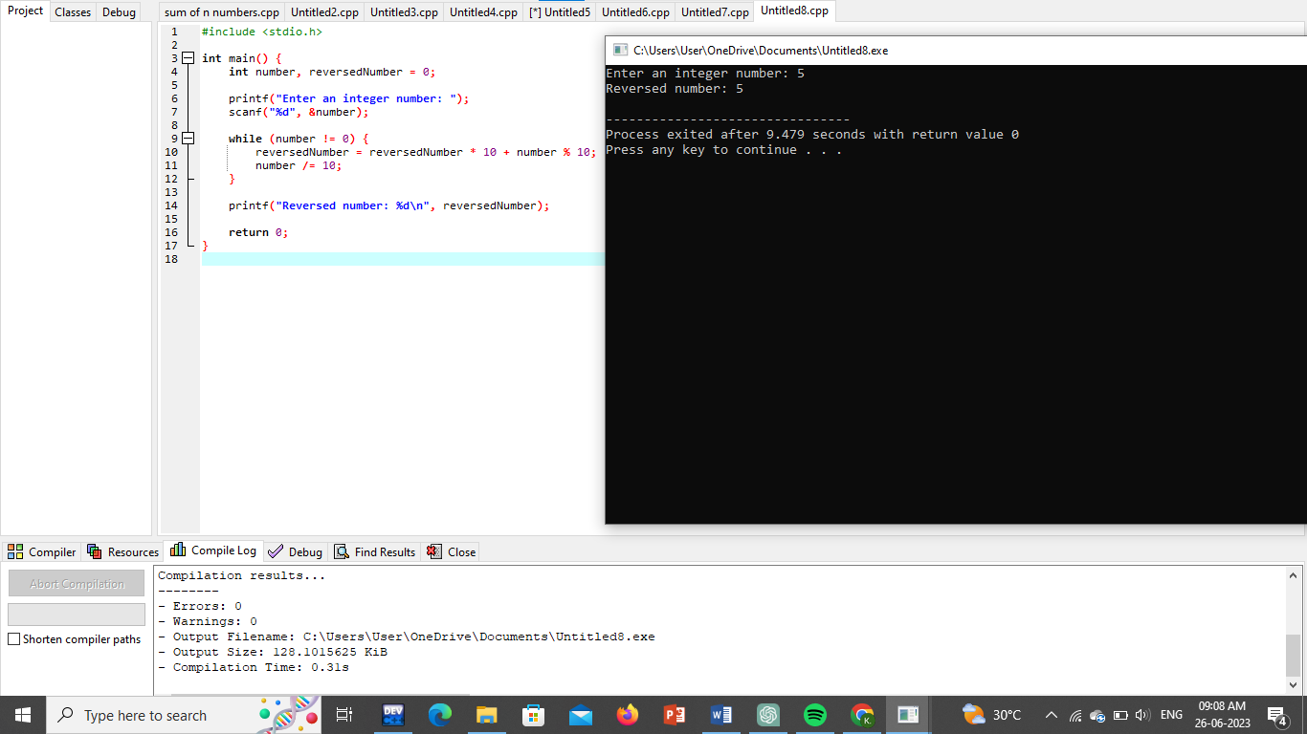

Program 20 : Finding whether the given integer is odd or even

